EXPT NO:2 | LOAD AND VISUALIZE A DATASET USING TABLEAU and PowerBI
DATE: 10.07.2026 | LOAD AND VISUALIZE A DATASET USING TABLEAU and PowerBI

PRE-LAB QUESTIONS (PROVIDE BRIEF ANSWERS TO THE FOLLOWING QUESTIONS)

1. Why is Tableau a preferred tool for data visualization?

Answer:
Tableau is preferred because it provides an intuitive drag-and-drop interface, making it easy to create interactive and visually appealing dashboards. It also supports fast data analysis with a wide range of charts and filtering options.

2. What is the primary use of a line chart in data analysis?

Answer:
A line chart is primarily used to display trends and changes in data over time. It helps identify patterns, increases, decreases, and fluctuations, such as changes in stock prices across different dates.

3. When would you use a tree map instead of a bar chart?

Answer:
A tree map is useful when comparing the proportions of multiple categories within a limited space. It is preferred over a bar chart when showing hierarchical data or part-to-whole relationships with many categories.

4. What is the significance of filters in Tableau visualizations?

Answer:
Filters allow users to display only the data relevant to their analysis, making dashboards more interactive and focused. They help compare specific categories, such as individual stocks or selected date ranges, without modifying the original dataset.

5. How does Tableau handle geographic data for visualizations?

Answer:
Tableau automatically recognizes geographic fields such as countries, states, and cities, and assigns geographic roles to them. It can then generate interactive maps with minimal configuration by plotting the data on built-in geographic maps.

IN-LAB EXERCISE:
OBJECTIVE:
To load a dataset into Tableau, create a variety of visualizations, and derive insights from the data using different chart types available in Tableau.
PROCEDURE:
Dataset Selection:
Use the Global Superstore Sales Dataset (available on Kaggle or Tableau's sample datasets).
Ensure the dataset includes fields like Order Date, Category, Region, Sales, Profit, and Customer Segment.
Data Loading:
Open Tableau and connect to the dataset.
Review the dataset structure, field data types, and missing values.
Chart Creations (Step-by-Step):
- Bar Chart:
Objective: Compare total sales by region and category.
Plot Region on the x-axis and Sales on the y-axis.
Add Category as a color dimension.
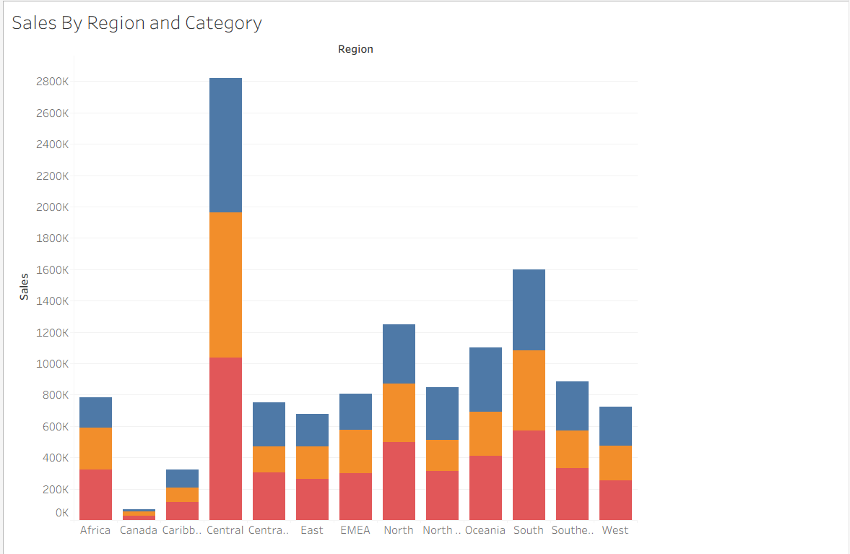

- Line Chart:
Objective: Visualize sales trends over time.
Place Order Date on the x-axis and Sales on the y-axis.
Set granularity to Month and color by Category.

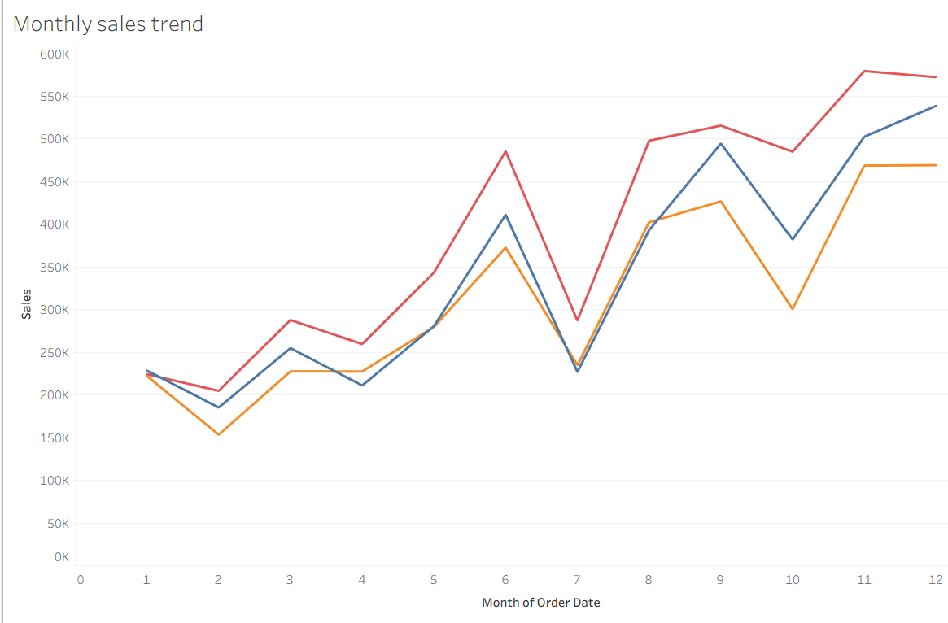

- Pie Chart:
Objective: Show sales distribution by product category. Assign Category as the dimension and Sales as the measure.

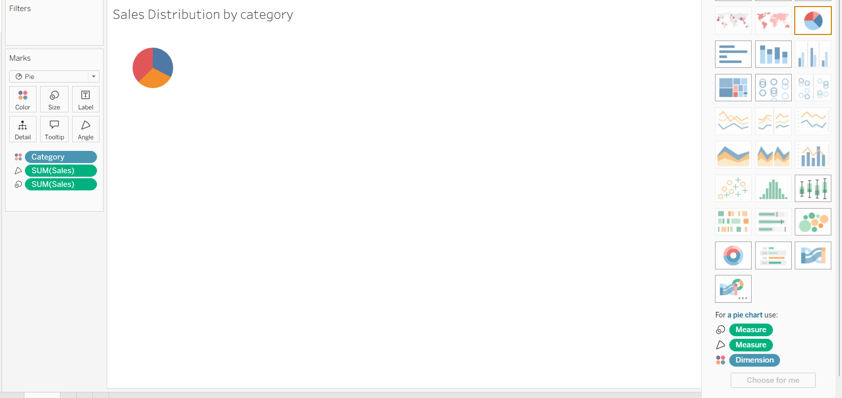
- Scatter Plot:
Objective: Examine the relationship between profit and sales.
Plot Profit on the x-axis and Sales on the y-axis.
Use Sub-Category as the color dimension.
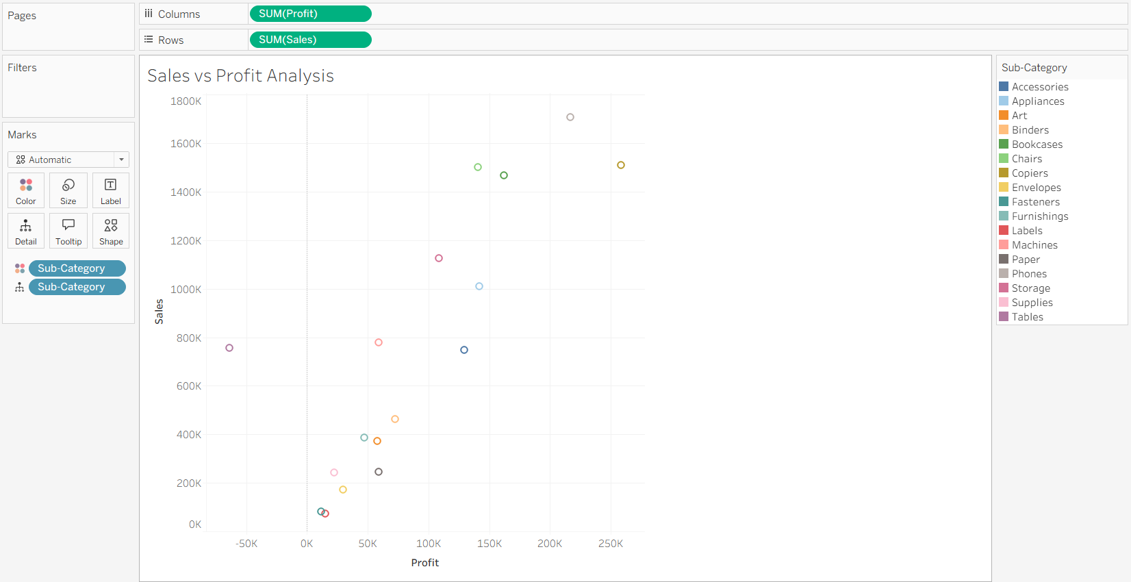
- Heatmap:
Objective: Compare sales across categories and regions.
Use Region and Category as dimensions. Use Sales as the measure and apply color coding.
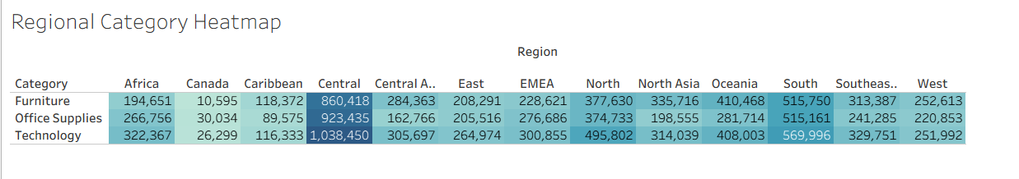

Dark colours indicate higher sales.
- Geographical Map:
Objective: Visualize total sales by country.
Set Country as the geographical field. Use Sales to define size and color gradients.

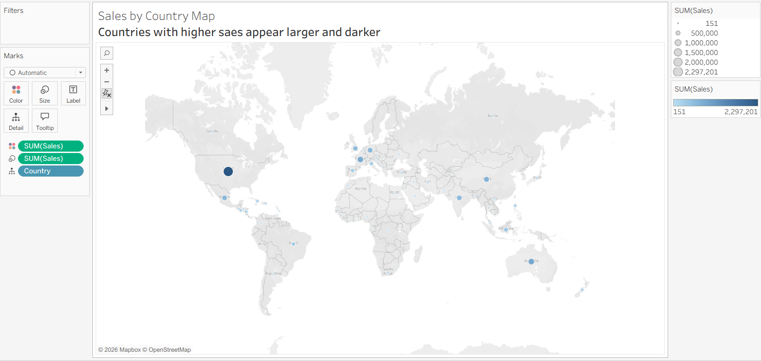
- Tree Map:
Objective: Display sales distribution by category and sub-category.
Use Category and Sub-Category as dimensions, and Sales as the measure.
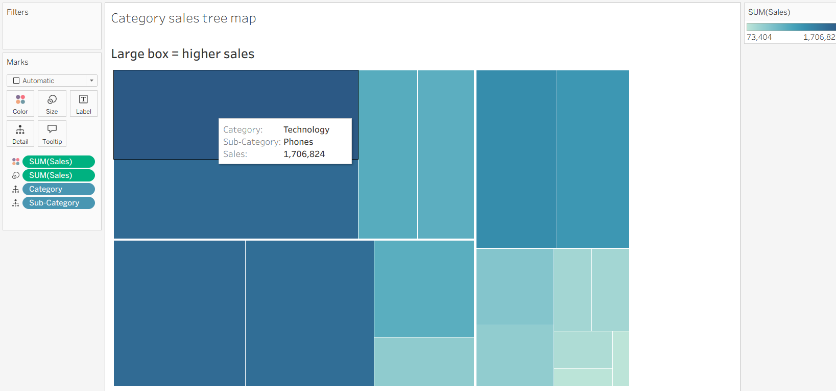
Customization and Interactivity:
Add filters to explore data subsets interactively (e.g., by year, region, or category).
Include annotations, labels, and formatting for clarity.
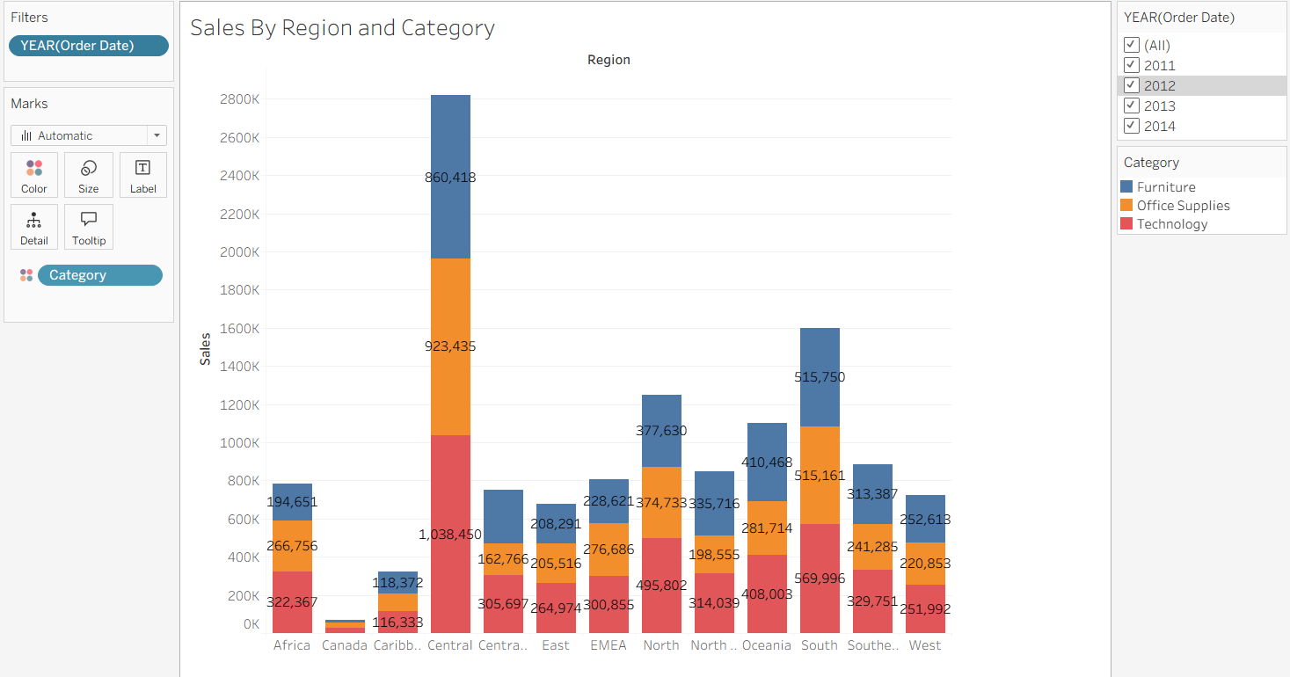

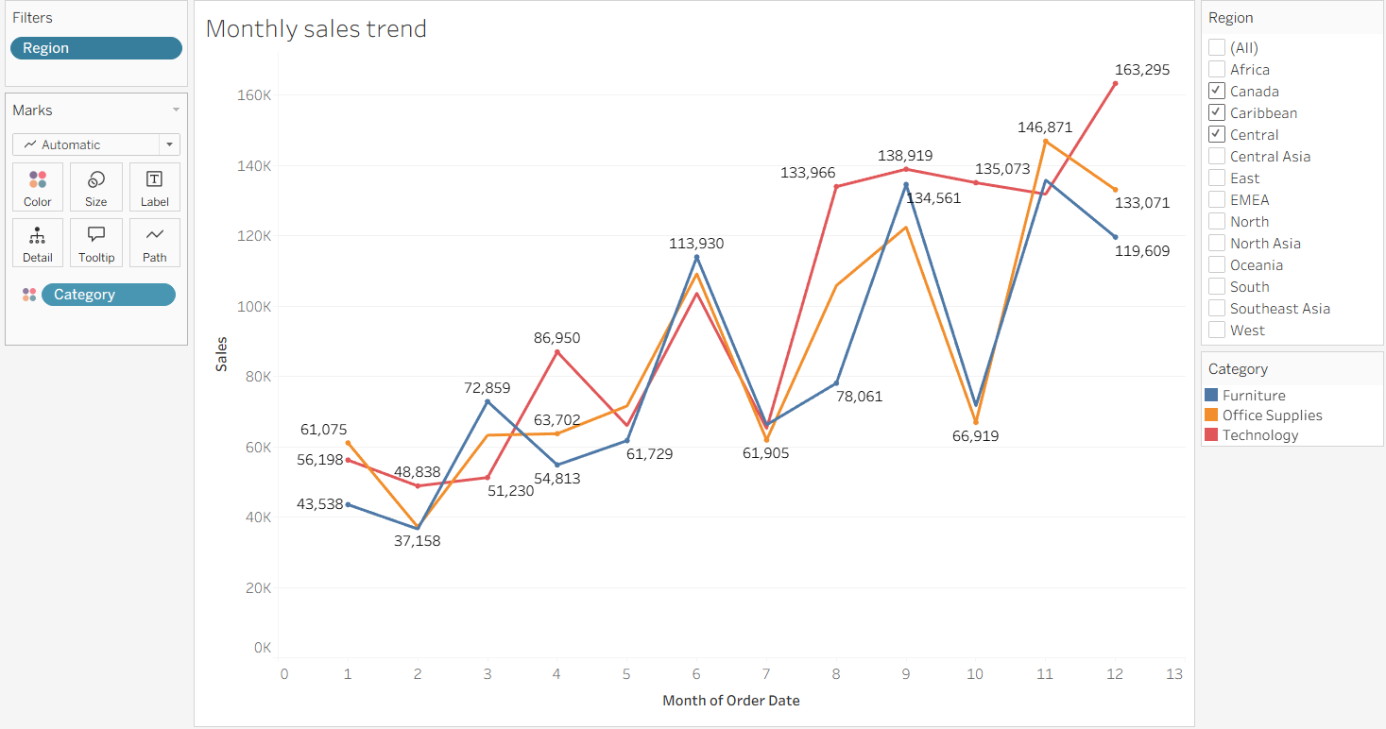

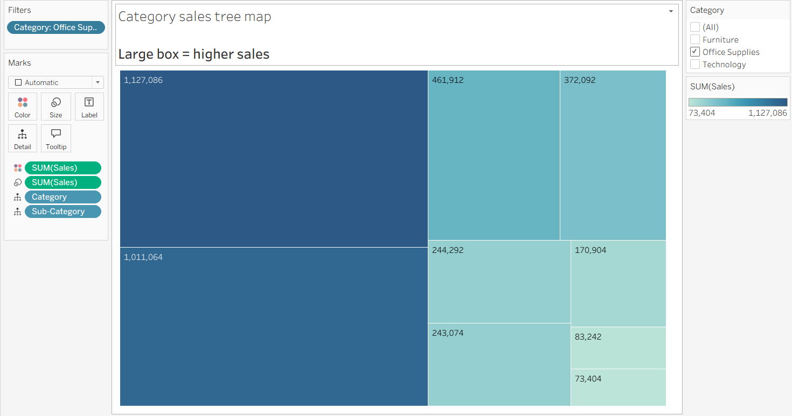

Dashboard Creation:
Combine all charts into a single dashboard to present a cohesive story.
Add interactive filters and tooltips for dynamic exploration.
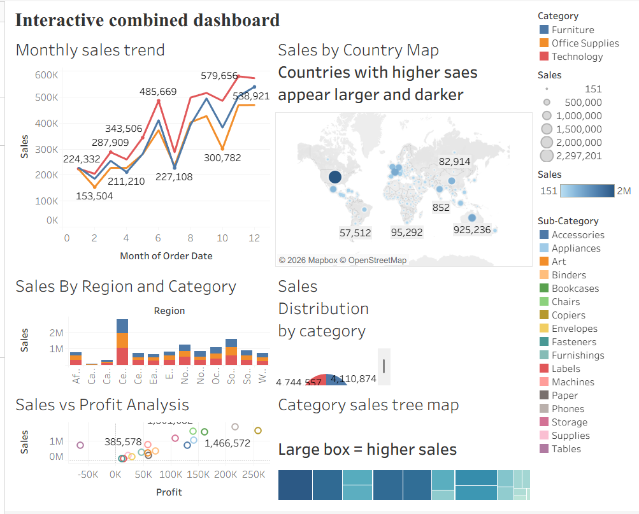
Experiment Dataset:
Global Superstore Sales Dataset
Source: https://www.kaggle.com/datasets/apoorvaappz/global-super-store-dataset
Fields Used:
Order Date
Region
Category
Sub-Category
Sales
Profit
Country

POST-LAB QUESTIONS (PROVIDE BRIEF ANSWERS TO THE FOLLOWING QUESTIONS)
Bar Chart:
1. What regions had the highest and lowest total sales?

Answer:
The region with the highest total sales can be identified by comparing the height of the bars in the chart. The region with the shortest bar represents the lowest sales performance, indicating areas that may require further analysis.

2. How does the performance of categories vary across regions?

Answer:
The chart shows that sales performance differs across regions for each category. Some regions perform better in specific categories, helping identify which products are more successful in different markets.

Line Chart:
3. Identify the month with peak sales.

Answer:
The month with the highest sales is identified by locating the highest point on the sales trend line. This indicates the period when customer demand and revenue were at their maximum.

4. Which category shows consistent growth in sales over time?

Answer:
The category with a steady upward trend in the line chart represents consistent growth. This helps identify categories with increasing customer demand and strong market performance.

Pie Chart:
5. Which category contributes the most to overall sales?

Answer:
The category with the largest slice in the pie chart contributes the highest percentage of total sales. In the Global Superstore dataset, Technology generally contributes a significant portion of overall sales.

6. Are there any categories with negligible sales contributions?

Answer:
Categories with very small slices in the pie chart represent lower sales contributions. These categories may need additional strategies such as promotions or pricing adjustments to improve performance.

Scatter Plot:
7. Is there a noticeable correlation between profit and sales?

Answer:
The scatter plot helps identify the relationship between sales and profit. Generally, higher sales tend to result in higher profit, but some points may show high sales with lower profit due to discounts or high costs.

8. Which sub-category shows the highest sales but low profit?

Answer:
The sub-category located at high sales values but low profit values represents products generating revenue but with reduced profitability. These products may require cost or pricing analysis.

Heatmap:
9. Which region-category combination has the highest sales?

Answer:
The region-category combination with the darkest color in the heatmap indicates the highest sales. This helps identify the strongest market segments and product combinations.

10. Identify any regions with poor sales performance across all categories.

Answer:
Regions showing lighter colors across most categories indicate weaker sales performance. These areas may need targeted marketing and business strategies.

Geographical Map:
11. Which country has the highest total sales?

Answer:
The country with the largest and darkest marker on the map represents the highest total sales. This visualization helps identify the most valuable markets globally.

12. Are there regions with minimal or no sales?

Answer:
Countries with small markers or no highlighted areas indicate minimal or no sales activity. These locations may represent potential expansion opportunities.

Tree Map:
13. Which sub-category dominates the sales in each category?

Answer:
The largest box within each category represents the sub-category generating the highest sales. This helps identify the best-performing products within each category.

14. Are there any sub-categories with unexpectedly low sales?

Answer:
Smaller boxes in the tree map indicate sub-categories with lower sales. These products may require further investigation to understand customer preferences and demand.

Dashboard:
15. What insights can you derive when combining all visualizations?

Answer:
The dashboard provides a complete overview of sales performance by region, category, time, and geography. Combining all charts helps identify profitable markets, popular products, and areas requiring improvement.

16. How do filters enhance the utility of the dashboard?

Answer:
Filters allow users to interactively analyze specific years, regions, and categories without changing the dashboard structure. They make it easier to explore detailed trends and compare different segments of the business.
ASSESSMENT

Description |  | Max Marks | Marks Awarded
Pre Lab Exercise |  | 5
In Lab Exercise |  | 10
Post Lab Exercise |  | 5
Viva |  | 10
 | Total | 30
 |  | Faculty Signature

